**SCHOLARS CORNER**

HARRISON DAVID ADDO

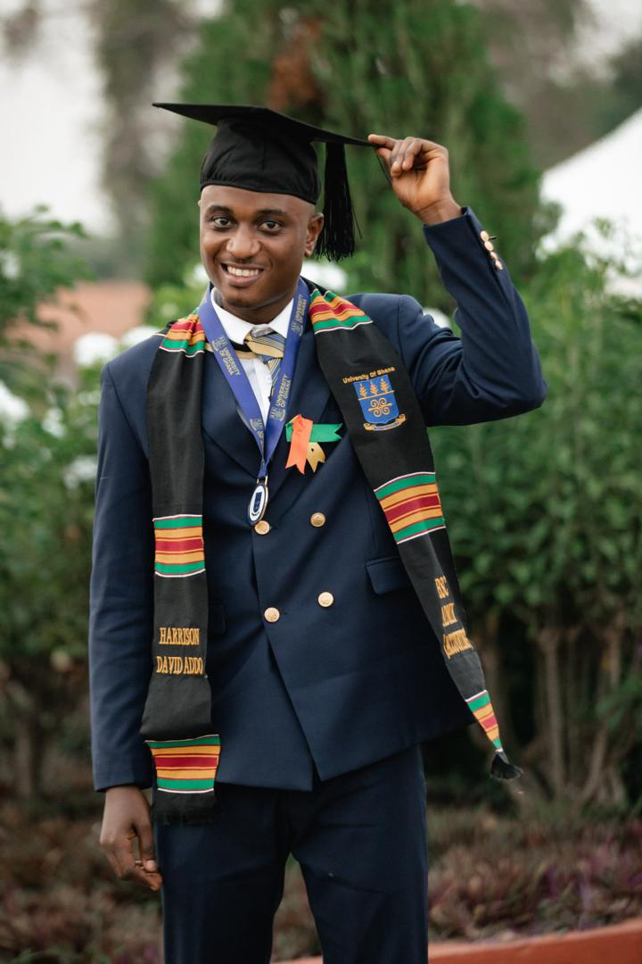

From where I stand, today is a testimony. I close my eyes, not in disbelief, but in sheer awe of the journey that has led me here. I remember standing on the edge of dreams, where hope was a flickering candle, easily swayed by the winds of doubt. The road was winding, rough, and at times, unbearably steep. But every fall taught me to rise, every stumble shaped my stride, and every doubt strengthened my resolve.

I am not just a student of books but a student of life. I have been taught by pages that turn slowly through sweat and perseverance and by the silence of nights spent wondering if this day would ever come. Yet, here I stand. Victorious. Not because my journey was perfect, but because it was real, raw, and relentlessly pursued.

As a charismatic Christian, a first-generation college student, a firstborn child, and mentor to my younger siblings, I cannot afford the luxury of failing my Creator, myself, my family, and my generation. The Akuapem Education Trust Scholarship lit a path that seemed dark and unreachable. It didn’t just offer financial aid; it gave me hope when hope was frail. It became a bridge over turbulent waters, and today, I cross it to meet my destiny. Graduating with a first class is not merely a certificate; it is a crown crafted through toil, sleepless nights, and prayers whispered into the wind.

The corporate world and job market have been tough to navigate after service. There have been moments where doubt attempted to creep in, but I stand here fuelled by the unwavering belief that the seeds I plant today will bear fruit tomorrow. I have hope and faith that every effort I make, every door I knock on, and every challenge I face is a step closer to fulfilling my personal legend and achieving my dreams. I will not relent until that day comes.

Today, I don’t say “I made it” as a solitary cry of victory but as a chorus. To every teacher, mentor, family member, and friend who poured into me, I say, “We made it.” This is our story, our triumph, our celebration.

And so, with every clap, every tear of pride, and every smile of encouragement in this room, I echo a resounding truth: “Truly, I have made it.” Thank you.

**ADELAIDE OPPONG GYAMPO**



Growing up was anything but easy. I live with my parents and siblings at Mampong Akuapem. Each day was a battle against poverty that seemed endless. Despite my parents’ tireless efforts to ensure that our needs are met, life kept hitting us with one heavy blow after another. I, just like all my siblings, had aims of perusing education to the highest level but these dreams were nearly shuttered by the struggles of life.

After I completed my Senior High School Education in 2019, furthering my education became an impossible dream as my parents could not afford finance my education any further. Due to this, I signed up for an apprenticeship but all the while I never lost the hope of furthering my education. One faithful day, as I was having a discussion with someone, he told me about Akuapem Educational Trust. I made up my mind to explore the opportunity. I read more about AET on the internet and acquired the link to their scholarship application portal and applied. A few days later, I was contacted by the AET office and invited for an interview. I attend the interview and by the grace of God I was selected to one the beneficiaries of their scholarship program.

I have benefited a lot from my encounter with AET, from their scholarship program, mentorship and personal development programs. With the help of AET I have now completed my tertiary education at the Presbyterian College of Education, Akropong - Akuapem. When I look back at how my life was before AET and how far I have come, TRULY, I HAVE MADE IT!

**SOLOMON OBUOBI**

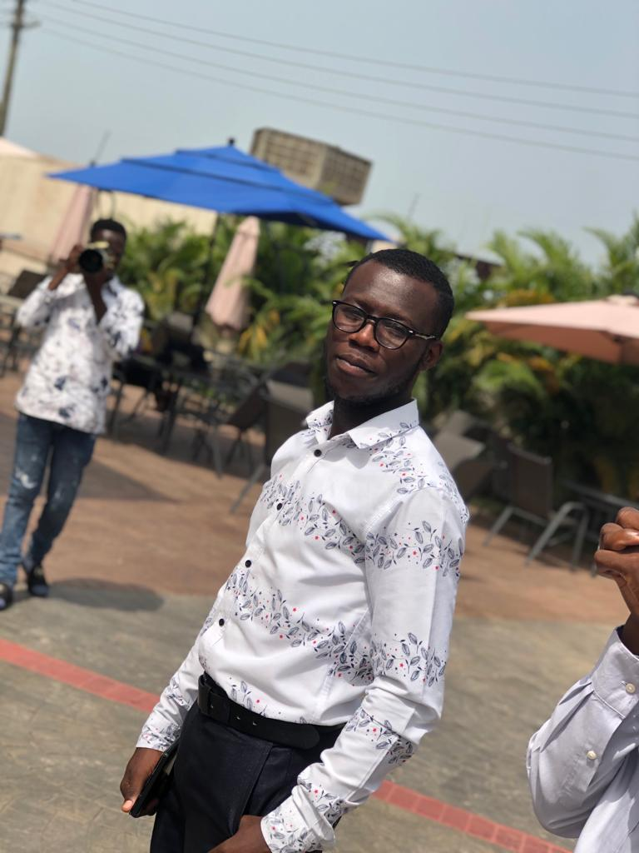

2020 is one of the years I will never forget in my life because of the fortunes it brought to me. Before 2020, I was really stuck in life and even considered all hope lost. I completed my Senior High School education in 2018. After completing, my aim was to climb higher on the education ladder but the financial conditions at home became a great obstacle. I nearly gave up on my dreams after all my efforts to raise funds to further my education proved futile.

On one hot afternoon in 2020, I saw a poster of Akuapem Education Trust on a wall calling for new applicants to be enrolled on their scholarship programme. I made inquiries about it just to know whether it is genuine and my findings proved positive. There, I realized the fragrance from my chamber is becoming visible in the channel of mystery. I applied and was later called for an interview and finally with God on my side, I was selected and became beneficiary of Akuapem Education Trust. This was when my dreams started resurrecting and I began envisaging a brighter future again. I always say, Akuapem Education Trust is the Messiah of my education.

My dreams have been resurrected by the timely intervention of AET. Now I am a level 400 student of Presbyterian College of Education and I can say with confidence that everything is on the right track. Ladies and Gentlemen, Akuapem Education Trust is there to give hope to the indigenes of Akuapem especially those of us who the society expect to fail because of our background. Before AET came onto the scene, I never thought I could be enrolled on any tertiary institution but here I am. It sometimes looks like a dream but truly, I have made it**!**

**As a passionate article writer let me leave you with two articles;**

* **Why Civilian Rule Is Better Than Military Rule.**

Our nation has experienced both civilian rule and military rule. The indigenous Ghanaian knows the importance and effects of both civilian rule and military rule and will bear me out that civilian rule is better than military rule.

Civilian rule is synonymous with democratic rule. This is a system of government where the people are allowed to choose their own leaders and can actively participate in public affairs. The flip side of this is military rule. This is a system of government which is established by force of arms. The leaders of the military regime are imposed on the people because they did not seek for the approval of the people through voting. Due to how they come into power, you can call them ***political armed robbers*** and you would not be far from right. Time has proven beyond dispute that civilian rule has the following benefits over military rule.

To set the ball rolling, civilian rule **protects the rights** and **freedom** of the citizenry. Civilian rule gives the opportunity for every citizen to express freely their concerns and takes into consideration if relevant. Since civilian rule is synonymous with democratic rule, ***every action taken by the leader is in accordance with the constitution*** and ***any*** ***deviation can be challenged at the law court*** and the ***compliant is assured of a fair trial***. In the civilian regime, ***no one can be detained without trial*** and it is always said of this regime that “No ***one is above the law***". This is the ***rule of law*** at work and a total respect for human right and freedom. This cannot be said of the military regime where there is an ***establishment of military*** ***court***, ***arbitrary*** rule and summary execution. Due to the lack of respect for human right and freedom, the decision of the leader is final and cannot be challenged. Citizens are detained without trial. This is a total disrespect to the rights and freedom of the people.

Secondly, the civilian regime is more transparent and accountable to the people than the military regime. I want to demystify the assertion that military regime come to sweep away corruptible civilian regime. For time has proven beyond dispute that this statement is a fallacy. These people come in promising to liberate the suffering masses. They come in accusing the ministers of the government they ousted of corruption and establish military court to deal with them. But in no time, these same people are seen doing worse off than those they ousted from office perpetrating their own rules. With their evil minds, they say they want to bridge the gap between the rich and the poor. They end up questioning the rich of their sources of wealth and confiscate some of their properties. Do we have to believe these desperados for cleaning the house? Or they are just envious of the rich? Theirs ways are too opaque and also not accountable to the people. But in the civilian regime, the government presents to parliament their budget every year. Parliament debates over it to make sure the interest of the people is prioritized. The leader presents to the people The State of The Nation's Address which tells the people what the nation has achieved and how the nation is surviving. This is pure transparency and accountability.

Moreover, the civilian regime manages the economy better than the military regime. The civilian regime is known to have economic team which is made up of competent professionals who come up with good economic policies and because of that, foreign investors get attracted. But in the military regime, all multinational companies wound up because of the fear of nationalization. This deters foreign investors and breaks down the economy. In their efforts to revamp the economy, they turned to leave the people worse off by taking rash economic policies.

Finally, civilian rule connects the nation to international communities better than the military rule. In the civilian regime, the nation can easily be part of international organizations such as United Nations Organization (UNO) and enjoy their benefits. A nation in an international organization would receive aids and grants for being a member. But in a military regime, the nation will be withdrawn from being a member and will be deprived of the benefits such as aids and grants.

In conclusion, considering the benefits of civilian rule such as rule of law; creating a conducive atmosphere for businesses which attracts foreign investors; providing accountability and transparency and connecting the nation to the international community. It is prudent that we protect civilian rule with every fibre in us and never trade it with military rule.

* ***UNEMPLOYMENT IN GHANA***

Ghana has over the years been faced with a number of crises. Among all the numerous challenges the nation has faced, one of the pressing ones which needs an urgent attention is unemployment. Concerned citizens have expressed their concerns about the rate at which the unemployment situation in Ghana is escalating. Unemployment is the situation where people who are in their active ages are willing to work to earn a living but cannot find any job. This means before a person can be labelled as unemployed, he or she should be willing and ready to work; and must be in the working age.

In the 1960s, graduates do not find it difficult to secure jobs after their education. The companies even woo them by placing notices on campuses so they could choose from. Life after graduation becomes a dream-come true. Unfortunately, for this generation things are not the same. Graduates after investing so much in their education find it extremely difficult to secure jobs. The situation has become so crucial that one can find unemployment even among doctors and engineers. What are really the causes of this menace? Profound investigations have revealed the following as the leading causes of unemployment in our part of the world.

First of all, our ***educational system*** is one of the leading causes of unemployment in Ghana. Education in Ghana is more **theoretical** **than practical** therefore the graduates come out with their academic certificates as their only hope in life. Most of the graduates in Ghana are **bearers of knowledge without any skills** which make it difficult for them to compete on the job market. Due to the **knowledge-acquisition-driven educational system**, the products of our universities are **job seekers** rather than **job** **creators** hence causing massive competition on the few vacancies available leading many graduates to be unemployed.

In furtherance of the above, the deep-rooted idea on the part of the graduates to engage in only ***white-collar jobs*** is also a major cause. Graduates from our universities have this traditional mentality that after their graduation they must work in offices, so any offer given to them which is not working in an office is often rejected. This mentality has caused the downfall of many graduates in Ghana making them unemployed.

Moreover, the ***inability of the government to create an enabling environment for private entrepreneurs*** is one of the leading causes of unemployment in Ghana. Looking at the turnouts of graduates from our universities every year, it is obvious that the government cannot employ all. Therefore, it is necessary for the government to create a good atmosphere that will encourage the private sector to expand their territories which will automatically lead to an increase in the employment rate. The **private sector of** **every nation is the engine of growth** and therefore should be well catered for by the government by creating an enabling environment such as **tax holidays** which will reduce their cost of operating. The sages say; “one **hand cannot cover the face of** **God**" so the earlier the government helps the private sector, the better it is to solve unemployment in Ghana.

Furthermore, the perversion of corruption by the leaders in Ghana is one of the causes of unemployment. While the youths are thirsty and hunger for employment to earn a living, the resource which would have been used to establish firms finds itself in the pockets of some leaders. The resources are diverted from national cake to family jollof. The little resources are used by the leaders to better the lives of their families to the detriment of the ordinary Ghanaian. For this reason, the suffering masses continue to suffer due to lack of employment opportunity leading to low standard of living.

To draw the curtains down on the causes of unemployment, another point which is worth mentioning is economic recession. When the economy is booming, a lot of economic activities take place which lead to the creation of employment opportunity. But when there is an economic recession, everything seems not to work. Economic activities reduce drastically hence the creation of jobs and eventually lead to unemployment.

How can these teeming and energetic youths survive without employment? Is unemployment really identified as a menace? How can it be solved? These are the questions that would be going on in the minds of concerned citizens. I therefore make the following suggestions.

First of all, the educational system must be reoriented to place more emphasis on acquisition of vocational and technical skills. Intense practice must be added to the theories so that the products of our universities will be job creators rather than job seekers. Therefore, the knowledge-acquisition-driven educational system needs to be changed to skills-acquisition-driven educational system.

Also, guidance and counselling needs to be intensified at our universities to help graduates understand that, white collar job is not the only source of livelihood.

The government must also create an enabling environment for the private sector to thrive and expand their territories.

One political canker needs to be eliminated; corruption. Supervision and auditing must be intensified to prevent the diversion of the national cake.

Finally, the government needs to re-structure the economy to make it buoyant. If the economy of Ghana becomes buoyant, it will spark off economic activities which will lead to more employment opportunities.

In conclusion, now the causes have been brought to the light with its clearly stated suggestions. I am optimistic that unemployment will be a thing of the past if the aforementioned suggestions are taken into consideration.

**Obuobi Solomon**

**Presbyterian College of Education**

**(Student)**

**Akuapem Education Trust**

**(Beneficiary)**

**ERNEST OHENE PIESIE**

The gentle hum of the city outside my window was a constant reminder of the world moving forward while I remained still. For an entire year, I watched life unfold around me from the comfort of my home, trapped by the constraints of financial hardship. The vibrant energy of university life beckoned, but the harsh reality of my situation kept me grounded. Each day, I would scroll through social media, my heart sinking as I saw friends embark on their academic journeys, making memories that felt forever out of reach.

I spent those days juggling part-time jobs that barely paid for my meals, let alone tuition. Yet, in the quiet corners of my mind, I held onto hope. I devoured books borrowed from the school library, fed my curiosity with researches, and kept my dreams alive through countless applications for scholarships during school time at senior high level and after school as well.

Then, one fateful afternoon, after applying for “AET” scholarship, an email notification flashed across my screen: "Congratulations! You have been selected for the Akuapem Educational Trust Scholarship." My heart raced as I read the words over and over, disbelief washing over me like a warm wave. I had earned a chance, a lifeline thrown to me when I least expected it. Within few weeks after participating in an interview with the AET, I packed my bags and stepped into the bustling campus, ready to embrace a new chapter.

Tertiary life enveloped me like a warm blanket. I was filled with excitement and trepidation, eager to learn and to make my mark. I immersed myself in my coursework, revealing in the intellectual challenges that came my way. Long nights were spent poring over PDFs and notes, coffee cups lining my desk like soldiers ready for battle. I found solace in the library, where the scent of old pages mingled with the quiet determination of students chasing their dreams.

As the years unfolded, I became part of a community that inspired and motivated me of moving forward. I joined study groups, participated in extracurricular activities, especially the entertainment side. My elders recognized my dedication, ability and talent, guiding me along the path with wisdom and encouragement. I learned to balance my time, prioritize my goals, and push through the obstacles that came my way.

Each semester brought new challenges, but also the thrill of progress. I remember the day I received my first semester results, marked with “first class Honor”. My heart swelled with pride; it felt as if I had conquered a mountain. As the years rolled on, that initial spark turned into a blazing fire. I began to understand that I wasn't just striving for grades. I was pursuing knowledge, seeking to contribute to a world hungry for change.

At last, after four gruelling yet transformative years, the moment arrived. Graduation day. Presentation of certificates and the get together made the ceremony very memorable. I was embraced with the feeling of happiness upon bagging Bachelor’s degree as the next phase of life. It felt surreal, a sweet vindication of all the sacrifices I had made, the sleepless nights, and the relentless pursuit of my dreams. I had made it.

Today, as am serving in my department, I reflect on the journey that brought me here. The challenges, the setbacks, and the triumphs have shaped who I am. I often think back to that year I spent waiting, knowing now that it was not a wasted year but a necessary pause that ignited my resolve. Life had tested me, but I emerged stronger, fuelled by resilience and the unwavering belief that dreams can become reality.

With my degree in hand and a career ahead of me, I embrace the future with open arms, ready to give back to others who dare to dream. I have made it, and this is just the beginning.

**ADU BEATRICE NKANSAH**



After years of dedication, hard work and perseverance, I can finally say that at last, I truly made it.

The journey has been an arduous one, but the feeling of accomplishment I am experiencing now is truly undefinable. A dream has turned into a reality.

The sacrifices, efforts and hard work that did not deserve to be wasted kept me awake, especially in moments of doubts and uncertainties, moments I wanted to give up and moments I questioned whether it was all worth it and if I had what it takes to succeed.

There were moments of triumph along the way, where I could see myself making progress and moving closer to my goal. These moments vitalized my motivation and determination to keep going, even though the road ahead seemed long and hazy. I knew that every small step forward was bringing me closer to my ultimate goal, and that was enough to keep me going.

In the pursuit of my goal, I poured my heart and soul into my work, constantly pushing myself to do better, sought mentorship and guidance from this noble organization, teachers and mentors and sharpened my skills to perfection.

Indeed, countless obstacles were imminent, but I pushed through, drawing on inner strength and resilience I didn’t even know I had. I relied on the support of this big family (AET), and my relatives who believed in me when I struggled to believe in myself.

At Last, I have truly made it and it was more than reaching a destination because it was about the person I had become along the way. I had emerged more strong, more resilient and determined. I have learned to cherish the value of patience, hard work and perseverance of not giving up on my dreams. I had discovered that success is not just about reaching a goal, but about the journey of self discovery and personal growth that comes with it.

As I stand at the peak of my success. I am filled with gratitude for everyone who supported me along the way; The Akuapem Education Trust, my family, mentors and colleagues - for playing crucial roles in helping me achieve my goals.

Long live The Akuapem Education Trust

Long Live Okuapemman. Long live Ghana.

**DANIEL OFORI**

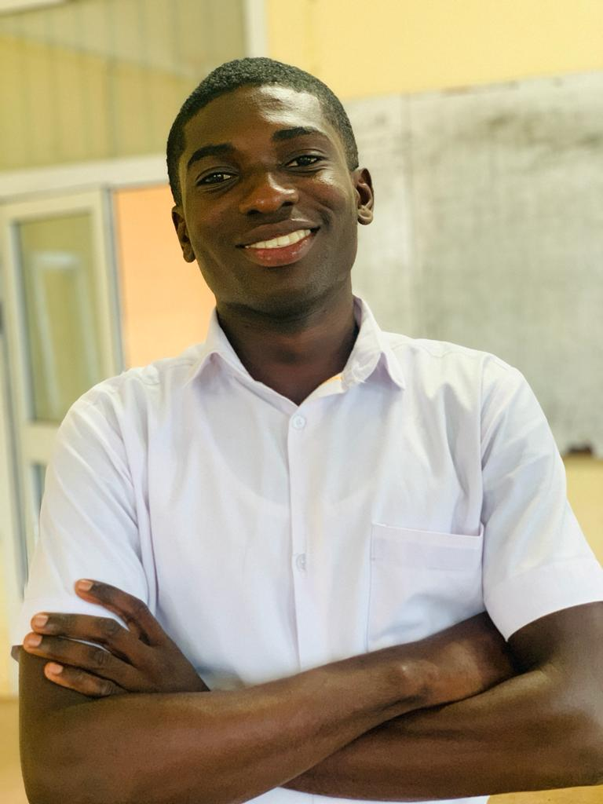

As an introvert, the thought of standing in front of a crowd and speaking used to fill me with dread. The fear of judgment and the anxiety of being in the spotlight often held me back from sharing my ideas and passions. However, everything changed when I participated in a Micro teaching practice organized by our college during the holidays. This experience became a turning point in my journey. This is how it all began.

My heart pounded with a mixture of anticipation and fear as I entered the classroom. It was daunting to think of teaching practice over the holidays for someone who had always dreaded public speaking. The thought that I would stumble, be judged, or fail to involve them kept on occupying my mind.

However, as I stood before the class with a lesson plan and newly found determination something inside of me changed. They looked at me with wide eyes, expectant, and curious; I realized that this was a rare opportunity to touch their lives forever. Every day, I took in a deep breath and moved beyond my doubts replacing it with enthusiasm for the subject matter.

I started from scratch by using some easy exercises in order to break ice and connect with students. Gradually, however steadily though not fast enough I felt my voice becoming stronger as well as more confident about being able to take their attention and explaining difficult ideas in ways they could relate to them. The more often that happened to me, the more frequently did I discover an unknown passion towards teaching within myself.  
  
Over time, I saw my students and me transform. My former familiar terror about public speaking began to diminish and was supplanted by a feeling of empowerment and pride. My words and actions could motivate these young minds. They caused curiosity in them.

Then one day when I stood before the class, teaching with confidence, knowing that fear of speaking in public was no longer part of me. At that moment, amidst the glowing eyes and happy faces of my students, I felt overwhelmed by gratitude and joy inside me. What had really happened then is that I had met some form of adversity, removed myself from my comfort zone and emerged stronger.

Truly, I have made it. My personal fears could not overcome me and I also experienced a new sense of completion and determination as a result of the transformative ability for teaching. Looking at the lot of people before me, I was sure that the journey was just starting with more chances for change and development. This led to my never-ending appreciation. Thank you AET for the confidence to be who I am today.

**OPARE PRISCILLA**



Growing up as a young girl in a humble family, it has always been my dream to be the one to change the story. However, along the line, those to help, mom and dad could not make it to help achieve the dream I have as a young girl. High school was tough but I was tougher, in high school when I lost my both parents, life seems to be to an untimely end, I was beginning to be depressed and think I will just have to learn trade after senior high.

But then, I still believe in God that there is still hope as long as I am alive. Some friends, even some families begin to lure me to trade learning after senior high, this is because, and they believe there is no one to help continue my education at the tertiary level. However, I kept the faith of furthering my education alive and I boldly told everyone around me that, I will go to tertiary by the Grace of God.

To the glory of God, my sister, whom I am staying believed in me and my WASSCE results, we began to raise funds towards my tertiary education. One thing to the other, to make the story wonderful by God, I was informed of the scholarship opportunity from the Akwapim Education Trust (AET). I was very happy to be picked after my application and going for an interview. In 2020, when I was given scholarship by AET will always be one of the good years in my memory. I started Presbyterian Women College of Education, Aburi in 2020 and I read Bachelor of Education in Primary Education. By the grace of God through AET who paid my school fees from 2020 till date, I am in my last semester of my tertiary education. I would not have been here if it should be my strength, but by the grace of God and AET, I could also say that I have truly made it happen.

**PRISCILLA NYARKOA ANTWI**

Alumnus, University of Education, Winneba

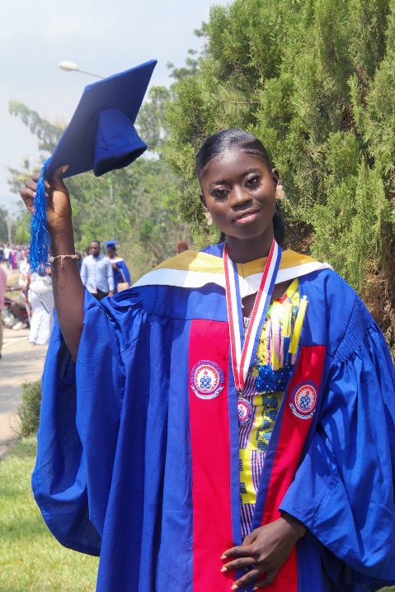

I still remember the struggles I faced in pursuing my education. Financial instability loomed over me, threatening to derail my dreams. Despite numerous scholarship applications, none seemed to come through. It was as if the door to my future remained locked.

But then, fate intervened. During a church service, I was introduced to the Akuapem Education Trust Fund (AET) Education Scholarship. With renewed hope, I applied and, by God's grace, I was awarded the scholarship.

The AET scholarship transformed my life. It not only alleviated my financial burdens but also instilled in me a sense of purpose and determination. I was able to focus on my studies, and my hard work paid off. Today, I stand tall as a degree holder from the University of Education, Winneba.

My journey has taught me invaluable lessons: hard work and determination are the cornerstones of success, and embracing failure fosters growth and resilience.

As I reflect on my journey, I realize that success is not a destination; it's a continuous process. I'm proud of the person I've become and the achievements I've made. Truly, I have made it.

I'm grateful to the Akuapem Education Trust Fund for believing in me and empowering me to achieve my goals. This scholarship has opened doors to new opportunities, and I'm excited for the next chapter.

To anyone facing similar challenges, I say: never give up. Keep pushing forward, and your breakthrough will come.

Truly, I have made it.

**JOSEPHINE NYANTEKYIWA SARPONG**

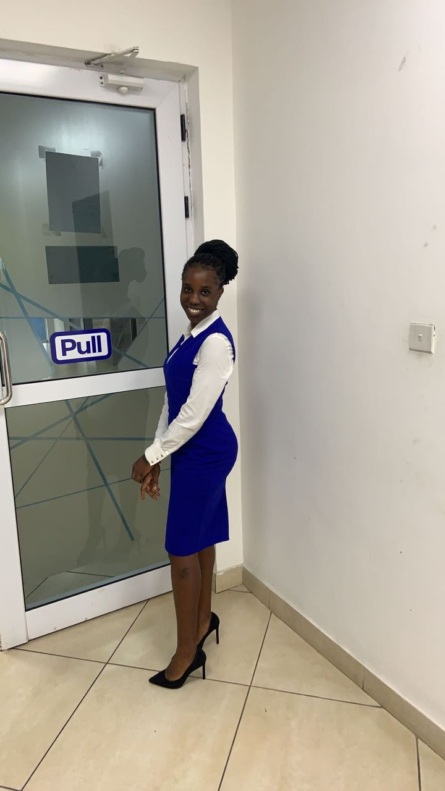

A proud AET scholar. Reflecting on my scholarship journey now that I’ve completed university fills me with immense gratitude and pride. It all began with a dream to pursue higher education, but the road was anything but smooth. I faced numerous challenges that tested my determination and resilience. Yet, I never lost sight of my goal.

When I found out that The Akuapem Education Trust Scholarship opportunity resonated with my aspirations, I poured my heart into the application. I shared my story and the hurdles I had overcome. Receiving that acceptance call felt like a turning point in my life. I was filled with joy and a renewed sense of purpose.

Now, as I stand on the other side of my university experience, I want to express my deepest thanks to the scholarship team. Your belief in me made this journey possible, and I am committed to using my education to make a positive impact in my community. Truly, I made it!

**DEBORAH SAFOWAA TAKYI**

As the sun dipped below the horizon, casting a warm golden hue across the quiet town, I sat on a stone under a tree reflecting on the whirlwind of everything that had transpired over the past four years. It all began innocently enough, a chance encounter with a kind gentleman who would forever be after the course of my life because my intension wasn't complete because of financial issues. Mr. Micheal Asare Bediako granted me a 4year scholarship to the University of Education (Winneba) to pursue a 4year B.A. Twi education.

I gladly and happily landed on the Fante land on the 10th of January 2021 for the course. Through his hands and AET as a team, I was taught how to embrace uncertainty, to take the risks, and how to appreciate the fleeting nature of life.

But then, as life often does it took an unexpected turn. As a 29-year grown woman, I met a man whom we got married and gave birth to a male child while in school. In an instant my free days were overshadowed by the weight of reality. Along the line, I struggled with the impending loss, circumstances around marriage that led my vibrant spirit dimming under the burden of sorrow. After two and half years, the treasure I hunted for lost its shell in my hands. It was a heart wrenching experience, one that left me feeling helpless and disgraced. In those dark moments, I learned the true meaning of support and compassion. My siblings, parents and some colleagues stood by me, offering a listening ear and a shoulder to cry on. They wanted to fix things for my pain to go so that I can concentrate on my academics, but they realised that some things are beyond their control.

Based on that I learned that sometimes, the best thing you can do for someone you love is simply to be there, to hold their hands and shave their griefs.

As i faced the losing of my matrimonial home, I witnessed both the fragility and resilience of the human spirit. I learned to appreciate the small moments, the laughter amid tears, and the strength that comes from vulnerability. When I finally emerged from the depths of my sorrow, I was different, stronger, yet more aware of the circumstances in life.

Sitting on the stone, I realized that two and half years have taught me far more than I could have ever anticipated. It was not just about adventure or embracing spontaneity; it was about love, loss and the profound connections we forge with others. The experience had reshaped my understanding of what it means to truly live.

As the sky faded into twilight, I took a deep breath, feeling a sense of gratitude wash over me. I had entered this journey seeking for excitement in getting first class but what I have found too is something far more valuable thus life experience, a son and a certificate and I can boldly say that truly, I have made it.

TRULY, I HAVE MADE IT

**ADDO EMMANUEL ATTUAH**



As I stand on the brink of graduating with a Bachelor of Science in Nursing from the University of Health and Allied Sciences, Ho, on November 30, 2024, I cannot help but reflect on the remarkable journey that has brought me here. This moment represents more than just an academic milestone; it is a celebration of resilience, opportunity, and the unwavering support of those who believed in me. Foremost among my supporters is the Akuapem Education Trust, a scholarship organization that made this dream possible. Their financial assistance lifted a significant burden from my family, enabling me to focus on my studies and personal development. It is because of their investment in my future that I can now proudly say, “Truly, I have made it.” A Journey of Growth and Transformation

When I entered the university, I knew the road ahead would be challenging, but I was ready to embrace it. With the financial support of the Akuapem Education Trust, I was able to dedicate myself fully to both academic excellence and leadership development. This scholarship was more than just financial aid—it was a gateway to countless opportunities for growth. Throughout my time at UHAS, I held key leadership positions that shaped my character and prepared me for the responsibilities ahead. As the Chief Justice of the Students’ Representative Council and President of the Nursing and Midwifery Students’ Association, I developed critical skills in teamwork, strategic thinking, and decision-making. These roles also taught me the importance of serving others with integrity and empathy, qualities that are central to both leadership and nursing.

The experience was not without its challenges. Balancing rigorous academic work with leadership responsibilities required discipline and perseverance. Yet, these challenges only fuelled my determination to succeed. They reminded me of why I started this journey: to make a difference in my community through the noble profession of nursing.

Impacting My Community has been key as a scholar of AET. The degree I have earned is not just a personal achievement; it is a tool for change. With this qualification, I am equipped to contribute meaningfully to the health and well-being of my community. Akuapem, my beloved hometown, faces challenges in healthcare access and delivery. As a nurse, I am committed to addressing these issues by providing compassionate and quality care. I plan to actively engage in health education and preventive care initiatives, particularly in underserved areas.

My vision is to empower individuals and families with the knowledge and resources they need to lead healthier lives. Beyond clinical practice, I aim to leverage my leadership experience to advocate for policies that improve healthcare systems at the local and national levels. I believe that sustainable development starts with healthy communities, and I am determined to be a catalyst for positive change.

To the Akuapem Education Trust, I extend my deepest gratitude. Your belief in my potential gave me the chance to realize a dream that once seemed out of reach. To my parents, thank you for your unwavering support and sacrifices. To my mentors and peers, your guidance and encouragement have been invaluable.

This achievement is not mine alone; it is shared with everyone who played a role in my journey. I hope my story inspires others to believe in the transformative power of education and the importance of giving back.

This is indeed a Call to Dream Big. To anyone reading this, let my journey serve as a reminder that with determination, support, and faith, no dream is too big. Seek opportunities, embrace challenges, and never underestimate the power of gratitude.

As I prepare to step into the next chapter of my life, I carry with me the lessons learned and the commitment to make a difference. This is just the beginning of a lifelong mission to serve, lead, and inspire. To Akuapem Education Trust, I say again: Truly, I have made it. Thank you for making it possible. Together, let us continue to create a brighter future for all.

Thank you.